Sprint 3 Report

Decentralized Application Framework (DAPPF)

Kirill, Anthony, Garrett, Shishir, Vincent

11/15/21

**Actions to stop doing:**

* The team should focus on smaller, more manageable tasks from user stories rather than larger tasks that are difficult to complete.

**Actions to start doing:**

* The team should start working on improving communication outside of meetings, and give progress updates when they are not able to attend meetings.

**Actions to keep doing:**

* The team should keep hosting consistent meetings and discussing progress updates.
* The team should continue putting in consistent time and effort into the project.

**Work completed/not completed:**

* Completed:
  + “As a developer, I would like to check the communication packet validity”
* Not Completed:
  + “As a developer, I would like to bind event listeners”
  + “As a developer, I would like to cache my user’s data”
  + “As a developer, I would like to implement runnables”

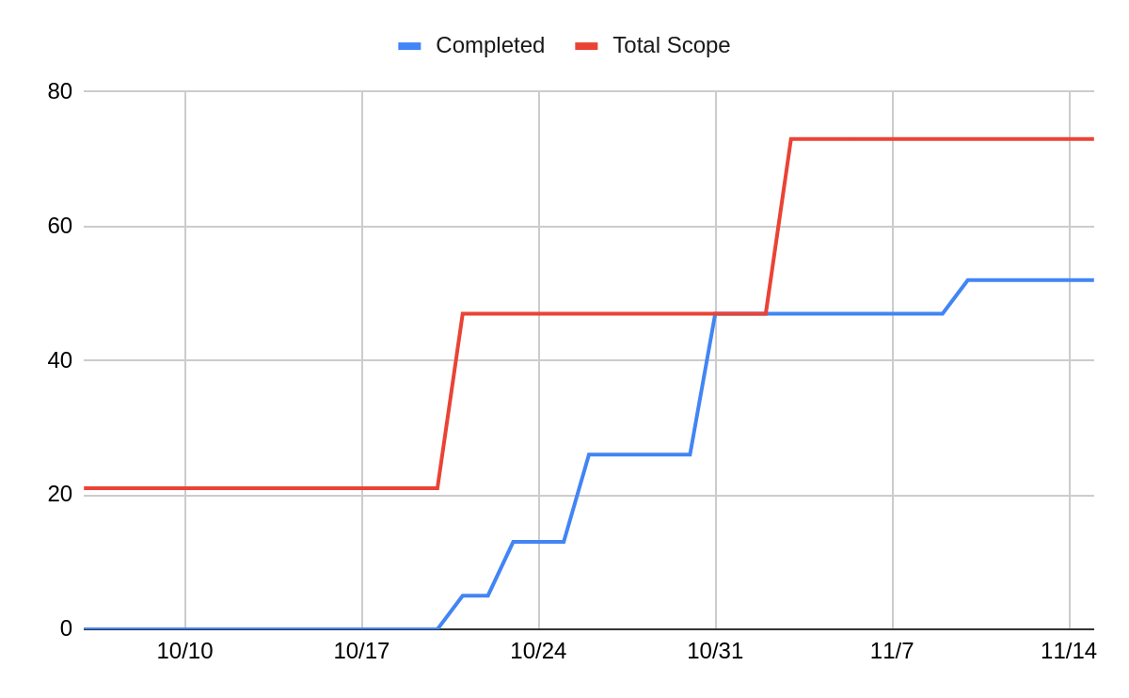

**Work completion rate:**

| **Sprint #** | Sprint 1 | Sprint 2 | Sprint 3 | **Average** |
| --- | --- | --- | --- | --- |
| **User stories completed** | 0/1 | 4/4 | 1/4 |  |
| **Estimated Work Hours** | 20 | 30 | 25 | **25** |
| **Number of days worked** | 8 | 8 | 8 | **8** |
| **User Stories/Day** | 0 | 0.5 | 0.125 | **0.208** |
| **Work Hours/Day** | 2.5 | 3.75 | 3.125 | **3.125** |